Question 1. Conditional

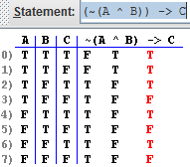

Question 2. Conditional

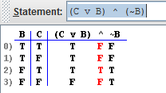

Question 3. Contradiction

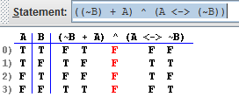

Question 4. Contradiction

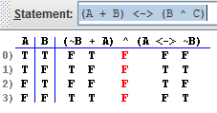

Question 5. Tautology

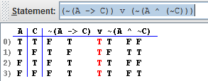

The column underlined in red is the one that has the final answer in it.

This web site formats it’s truth tables as the whole statement and then they stick the true or false values underneath each different section of the statement.